Decision Making Statement
____________________________________________________________
Decision making statement is used for work with conditional programming.
Means if we have some condition and if we want to check then we can decision making statement.

Types of Decision Making Statement
________________________________________________________
1. Simple if statement
2. If else statement
3. Else if ladder
4. Nested if statement
5. Switch statement

Now we want to discuss about simple if statement
___________________________________________________
Syntax of simple statement
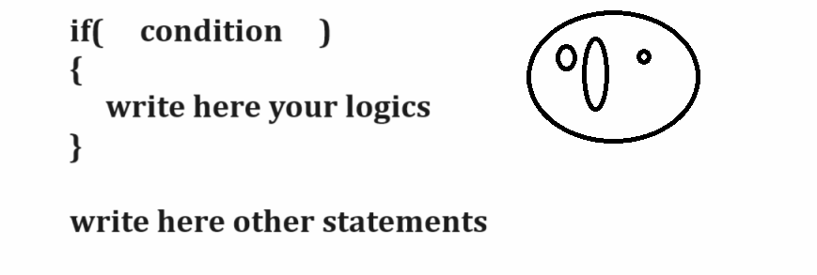
Example with source code
import java.util.*;
public class SimpleIfApp
{ public static void main(String x[])
{ Scanner xyz =new Scanner(System.in);//
int a,b;
System.out.println("Enter two values");
a=xyz.nextInt();
b=xyz.nextInt();
if(a>b)
{ System.out.println("A is Greater");
}
if(b>a)
{ System.out.println("B is Greater");
}
if(a==b)
{ System.out.println("A is Equal with B");
}

}
}
If else statement
When we have two conditions exact opposite of each other then we can use if else statement.
Syntax:
if(condition)
{ write here your logics
}
else{
write here your logics
}
other statement
Note: if your condition in if block is true then execute if statement otherwise execute else block.
Example with source code
import java.util.*;
public class SimpleIfApp
{
public static void main(String x[])
{
Scanner xyz =new Scanner(System.in);//
int a,b;
System.out.println("Enter two values");
a=xyz.nextInt();
b=xyz.nextInt();
if(a>b)
{ System.out.println("A is Greater");
}
else{
System.out.println("B is Greater");
}

}
}
Example: WAP to input the quantity and rate of product and calculate its total bill and if bill is greater than 10000 then apply 10% discount on bill if bill is less than 10000 then apply 2 % discount on bill.

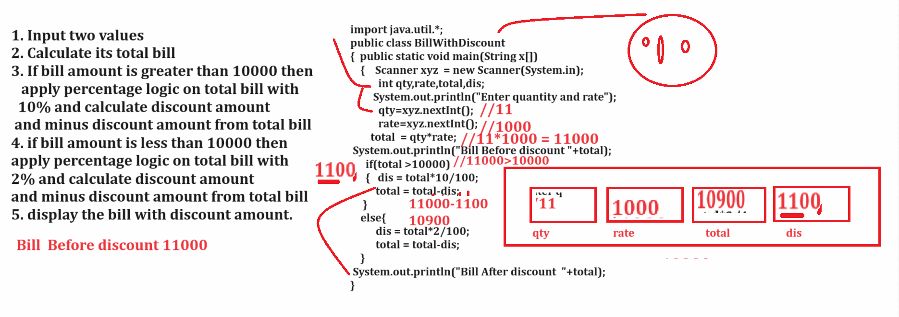

Example: WAP to input character from keyboard and convert lower case character to upper case and upper case character to lower case.

Note: if we want to work with any character data then we should have to know the ASCII code

Q. What is ASCII Code?
______________________________________________________________
American Standard code for information and interchange called as ASCII.
Def: ASCII is intermediate language which is used for store every key on character as digit in system.
There are total 256 ASCII code is there.

Digit: 0- 48 to 9-57
Capital Letters: A = 65 to Z= 90
Small letters: A = 97 to Z=122

Example
import java.util.*;
public class CharConvertApp
{
public static void main(String x[])
{ Scanner xyz = new Scanner(System.in);
char ch;
System.out.println("Enter character");
ch=xyz.nextLine().charAt(0); //use for single character input
System.out.printf("Before Convering character is %c\n",ch);
if(ch>=97 && ch<=122) //ch>='a' && ch<='z'
{
ch= (char)((int)(ch-32));
}
else{
ch= (char)((int)(ch+32));
}
System.out.printf("After converting character is %c\n",ch);

}
}

